**Avocado Field Walk**

**APRIL 21st 2016 9.30am**

**187 Pipe Clay Gully Rd, Manjimup**

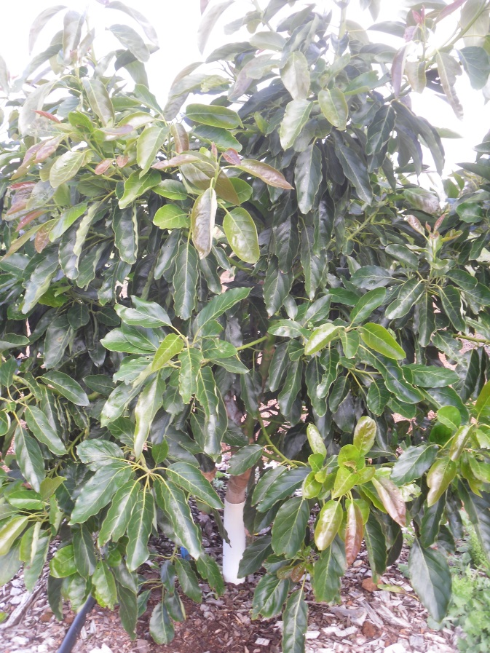 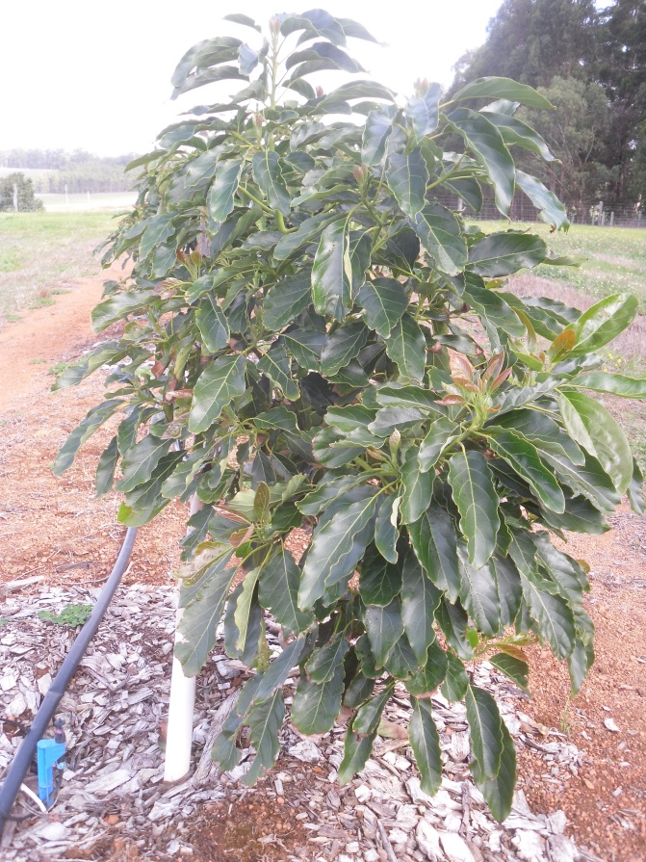

Please notify Kathy at

**Warren Catchments Council**

if intending to attend.

Ph 97718180 or email [kathy.dawson@warrencc.org.au](mailto:kathy.dawson@warrencc.org.au)

1/04/2016

1/04/2016

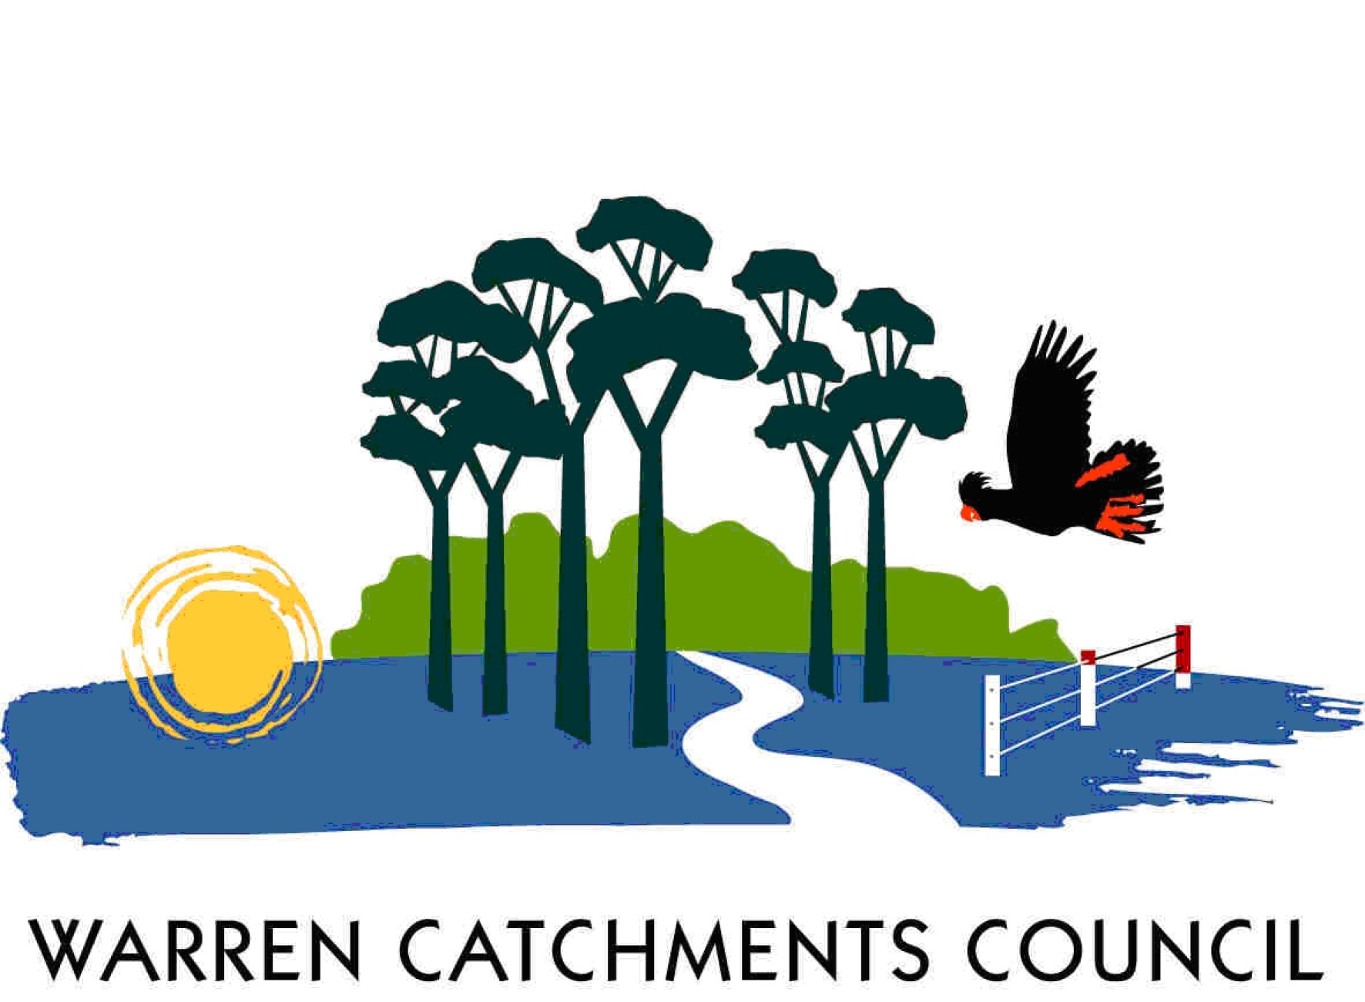  

*The South West Catchments Council supports this project, through funding from the Australian Government and the Government of Western Australia*

These photographs are of a randomly selected matched pair of avocados. The tree on the right was planted late October 2014 as per standard practice.

The one on the left was planted three weeks later into soil that had been amended by incorporating biochar into the planting bed.

Will the advanced growth result in earlier production returns?

Will biochar amended soils increase the trees resilience to pest, disease, stresses induced by frost, heat, saline water or phytophthora?

Will the nutrient scavenging mycorrhizal fungi, whose function is enhanced by biochar, influence fruit size or oil content?

Do we need to invest avocado levies locally to find answers to these and other questions?