An invitation to
AVOCADO PRODUCERS
to visit Doug Pow’s experimental site
187 Pipe Clay Gully Rd, Middlesex, Manjimup
for a brief establishment description and visual check
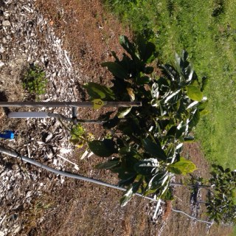
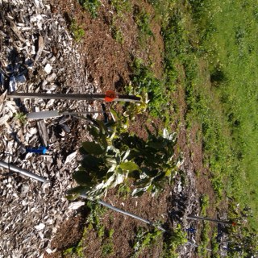
4pm,
Friday 4th December, 2015
Control
Tree 9
Treatment
Tree 9

Brief Background
Results of the first year into a three year trial to assess the capacity of biochar to amend the physical properties of the soil, across three soil types, to more closely simulate that of the avocado’s native environment and enhance its performance are impressive.

Treatments of 5%, 10% and 20% v/v biochar/topsoil addition are matched with a control row. Significant growth differences are apparent between the treatment rows and the control. However there are no discernible differences between the treatment proportions, suggesting more is not necessarily better.

The first round of tissue testing has revealed only one significant difference between treatment and control rows – that is a 23% reduction in chloride levels of the treatment row.

This low budget research trial, funded by the National Landcare Programme, is limited in the scope and frequency of testing. Given the unexpected benefits not covered by the project’s terms of reference, additional funding will be sought to investigate further.

RSVP: Warren Catchments Council Ph 97718180 or email kathy.dawson@warrencc.org.au

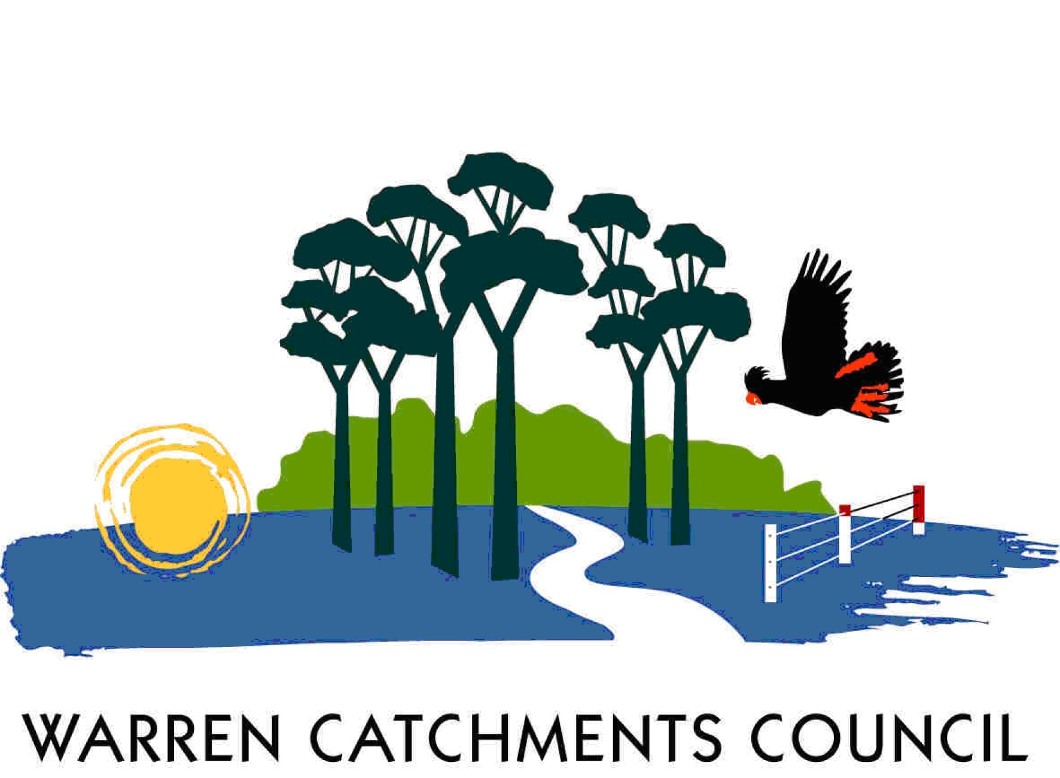

The South West Catchments Council supports this project, through funding from the Australian Government and the Government of Western Australia

